**Mr. Visca’s: Calculus (Chpt 4.3)**

**Chpt 4 – Day 4: Connecting f’ and f”**

**4.3 Connecting f’ and f”**

**Theorem 4: First Derivative Test for Local Extrema**

*applies to continuous function f(x)*

***CRITICAL POINTS****...where slope (or f') is ________________________________*

* *if f' changes signs (value) from - to +, then there is a ____________________________*
* *if f' changes signs (value) from + to -, then there is a ____________________________*
* *if f'<0 from left endpoint, a, for x>a, then the endpoint is a _____________________*
* *if f'>0 from left endpoint, a, for x>a, then the endpoint is a _____________________*

* *if f'<0 from right endpoint, b, for x<b, then the endpoint is a _____________________*
* *if f'>0 from right endpoint, b, for x>b, then the endpoint is a _____________________*

***CONCAVITY***

***INFLECTION POINTS****...where f" is _____________*

* *if f" is negative value, the function is concave _______________*
* *if f" is positive value, the function is concave _______________*

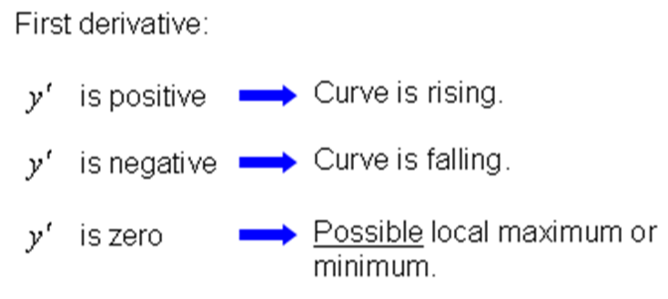

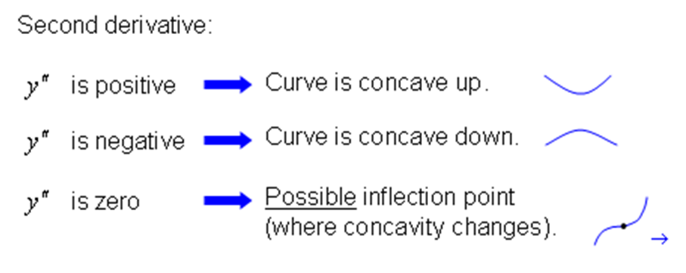

Example: Find any extreme values, points of inflection, and graph y = x3 - 3x2 + 4.

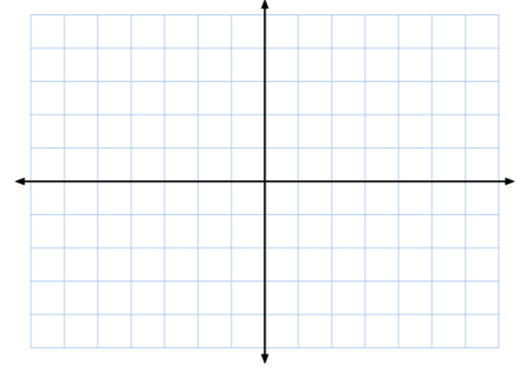

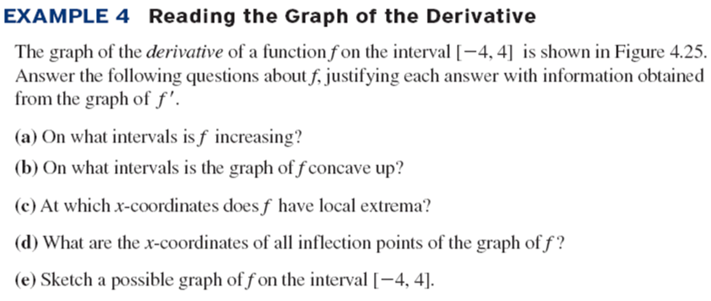

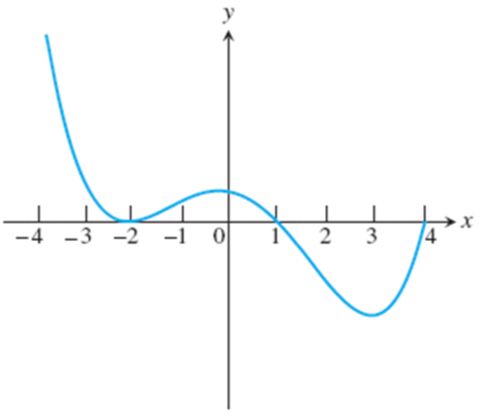

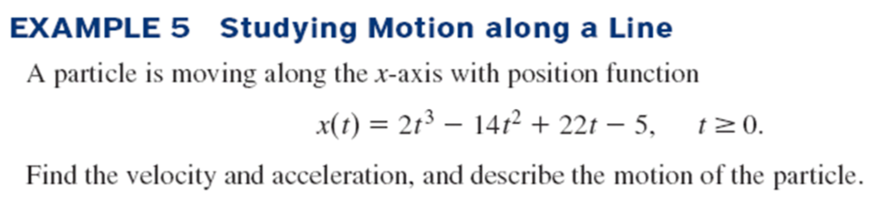

**Homework:**

**section 4.3 (1-15 odd, 18, 21-30 all)**